**Classroom Rules**

**1) Please follow directions given by the teacher the first time.**

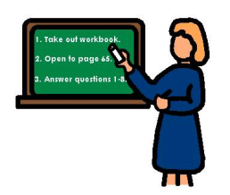

**2) Raise your hand when you have a question or when you want to answer a question.**



**3) Keep your hands and feet to yourself.**

**C:\Users\Owner\AppData\Local\Microsoft\Windows\Temporary Internet Files\Content.IE5\TB0TZCEW\MC900383320[1].wmf**

**4) Please pay attention by keeping your eyes on the speaker.**

**C:\Users\Owner\AppData\Local\Microsoft\Windows\Temporary Internet Files\Content.IE5\STVLW815\MC900187159[1].wmf**

**5) Put all materials back in their original places.**

